

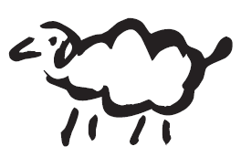

Custom Bike Guide

Your guide for selecting the perfect hand-made bicycle

Thank you for choosing Black Sheep Bikes! This Custom Bike Guide will help us get to know you, your riding style, and what kind of bike will suit you the best for the application needed. Please fill out this guide as complete as you can. Your order will be placed upon receipt of your non- refundable $1000 deposit. If you have any questions, don’t hesitate to write or call us. We look forward to creating your ultimate ride.

Step 1: What style of frame do you want?

Frame Style:

**Mountain:**

High Light Soft Tail- 44mm headtube, Bladed Suspension, 95mm travel, Fox CTD, 12mm thru-axle

Stellar- Twin Cantilever, positive single-arc top tube

Luna Vista- S-bend Twin Cantilever and top tube, bridged seat tube and top tube

Stelleon- S-bend Twin Cantilever, positive single-arc top tube

NONAME- S-bend top-tube, positive arc seat stays

High Light- positive single-arc top tube, seat stays and tank tube

High Roller- positive single-arc top tube and seat stays, straight tank tube

Zamer- 36er, any style

Sholeline- double diamond

Speedster- Twin top tube and cantilever stays

**Road**:

Speedster- Twin top tube and cantilever stays

Northdam- Double Diamond

**Cyclocross:**

Pine Ridge- Double Diamond

**Fat:**

Any Style Frame

**Tandem:**

Any Style Frame

Details:

Frame Style: _______________

Wheel size: _____

Brake type: _____

Gearing: _______________

Clearance for largest tire size: _____

How many H2O Bottle mounts? _____

Other ____________________________

***Frame and Fork Options***

HACS- *horizontally adjustable chainstays*

S&S Couplers- *1 ¼ - 1 ¾ “ travel tube-splitter*

Paragon Sliding Dropouts- *for single-speed or internal hub*

Paragon Rocker Dropouts- *for single-speed or internal hub*

Paragon Hooded Sliders- *for single-speed or internal hub*

Extra H2O Bosses- (*2 sets included in bike build)*

Internal Cable Routing

Rack and Rear Fender Mounts- *5mm bolts*

Extra brake mount- *disc, V, cantilever*

Jen Green Badge- *sterling sheep, or custom badge*

Paragon Tube Splitter- *for belt drive*

Paragon Travel Splitter

Fast Back Travel- *wish-bone style travel splitter*

Bottle opener

***Media Etch***

Negative- *negative word mark and sheep, bands on each end*

Positive- *Positive word mark and sheep logo*

Custom etch- _____________________________________________________________________

***Forks***

Faith- *Trussed fork*

Unicorn- *single-crown, straight or curved blades, 1 1/8” steerer* Butterfly- *single-crown, 1 ¼” curved or straight blades, tapered streerer*

Road- *Straight or curved swaged blades*

***Bars***

Lone Star- *Three Piece welded*

Mountain Moustache- *six bend, 12-70 degree sweep*

Scorcher- *four bend, drop rise or flat*

Riser- *four bend mountain bar*

Flatter - *two bend* One-Piece Bar-Stem- *any bar-stem combo*

***Stems***

Paragon Face plate- four bolts, sheep logo

***Seat******Post***

Thomson head- black or silver, straight or set-back

Options:

Fork: _______________

Bar: _______________

Stem: _______________

Seat Post: _______________

Step 2: What is your riding style?

Rate the following on a scale of 1 to 10. 1 = Heck No! 10 = Heck Yeah!

I love going uphill as fast as possible ________

I tend to stand when I climb ________

I love descending technical lines ________

I don’t want to feel every bump in the road ________

I enjoy railing the corners ________

I ride every day, all year round ________

I jump off every drop and rock ________

I like to cruise at my own pace ________

I prefer comfort over performance ________

I feel uncomfortable descending ________

Briefly describe your typical ride: ________________________________________________________________________________________________________________________________________________________________________________________________________________________________________________________________________________________________________________________________________________________________________________________________

What are your goals for riding this year? ________________________________________________________________________________________________________________________________________________________________________________________________________________________________________________________________________________________________________________________________________________________________________________________________

What are you expecting out of your new bike?

________________________________________________________________________________________________________________________________________________________________________________________________

What do you like and dislike about your current bike?

________________________________________________________________________________________________________________________________________________________________________________________________________________________________________________________________________________________________

Step 3: Determining Fit

We want to ensure that you and your bike go together perfectly. Proper fit will allow greater performance, comfort, handling, and enjoyment. There are three options to determine your bike’s geometry.

1. You can fill out the following Fit Guide, and send this to us.
2. You can visit us in Colorado, and we can perform a fitting in person
3. You can have a fit done, by a certified fitter, and supply us with that info.

Fit Guide:

We use a combination of methods to determine the geometry you need. We will need static body measurements – inseam, torso length etc…

Static Body Measurements:

Please take all measurements in CENTIMETERS!

Height _______

Weight _______

Body length A _______

Inseam B _______

Femur Length C _______

T/F Length D _______

Arm Length E _______

Shoulder Width F _______

Shoe Size _______

Width of Palm _______

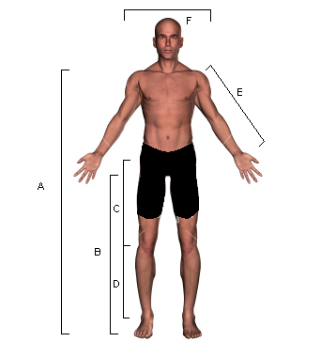

A: Body Length is measured from the floor, with bare feet, up to your collarbone.

B: Inseam is measured from the floor up to your crotch. Firm pressure.

C: Femur Length is measured from Greater Trochanter (bony protrusion on side of hip) to the side of your knee, at the level of the middle of your Patella (kneecap)

D: Tib/Fib length measures the distance from the side of your knee (same as above) to the middle of your lateral Malleolus (ankle)

E: Arm Length is measured from the Acromion Process (bony point of shoulder) to the middle of your palm. It helps to hold a dowel or broomstick to find the true center of your hand.

F: Shoulder width is your overall widest point from shoulder to shoulder.

Existing Bike Geometry:

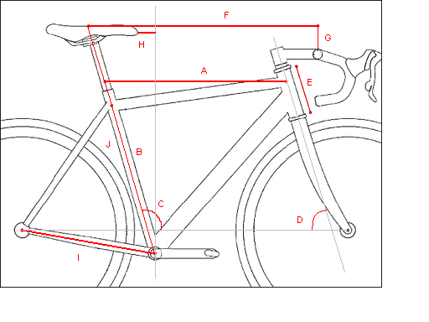

A __________

B __________

C __________

D __________

E __________

F __________

G __________

H __________

I __________

J __________

Please fill out the existing bike geometry with all measurements in centimeters

A: Effective Top Tube – a horizontal line from the center of the top tube/head tube junction back to the center of the seat tube or seat post.

B: Seat tube length – measure from the center of the bottom bracket to the center of the seat tube

C: Seat tube angle

D: Head tube angle

E: Head tube length – don’t include headset!

F: Cockpit reach – again a horizontal measure from the middle of your seat to the center of the bars

G: Drop – a vertical measure from the top of the saddle to the top of the bars at the clamp.

H: Setback – a horizontal measure from the tip of your saddle to the center of the bottom bracket

I: Chainstay length

J: Seat Height – from the center of the bottom bracket to the top of the saddle

If you have any questions on how to get these measurements, please contact us.

Pictures

Any Pictures of the current bike you ride, you riding your current bike, ideas for your new bike, or any other details you would like considered on your new bike, please send to the email bellow.

Step 4

Any other notes or details?